SIMATS ENGINEERING (SAVEETHA SCHOOL OF ENGINEERING)
Department of Computer Science and Engineering
ASSESSMENT TOOL 3 – FUNCTION CALLING & STRUCTURED OUTPUT TASK
Course Code: | CSA65 | Course Title: | Generative AI and Large Scale Models
CO Assessed: | CO2 – Precision (BL2, BL3) | Assessment: | Assessment Tool 3 – Function Calling & Structured Output Task
Weightage: | 40% of CIA | Total Marks: | 1 * 100 = 100 (1 Question1)
CO2 Statement: | Apply prompt engineering techniques and utilize pre-trained Large Language Models through modern AI frameworks and APIs to solve real-world problems (BL2, BL3)
Student Name: | N.MANASA | Reg. No.: | 192472031
Section / Batch: | CSE-AI | Date: | 04-08-2026

Instructions to Students
· Answer 1 question. Total: 100 Marks.
· Analyze the given scenario and identify the appropriate function(s), tool(s), parameters, and structured output required to solve the task.
· Design a valid function-calling schema with appropriate function names, parameters, data types, required fields, and descriptions based on the given requirements.
· Implement the function-calling workflow demonstrating the complete process: User Query → LLM → Function/Tool Call → Function Execution → Structured Response.
· Ensure that the generated output strictly follows the defined structured format or JSON schema and contains valid, relevant, and consistent information.
· Clearly document the designed schema by explaining the purpose of each function, its parameters, data types, required fields, expected input, and expected output.
· Briefly justify the design decisions and explain how function calling and structured output improve the reliability, consistency, and usability of the LLM-based application.
Submission Requirements
Students should submit:
- Source code / Jupyter Notebook
- Function-calling schema
- Structured output/JSON schema
- Execution screenshots
- Test cases and results
- Brief documentation explaining the schema and function-calling workflow

Code of Conduct
I N.MANASA(192472031) (Name / Reg No) certify that this submission is my original work and that I have adhered to the guidelines specified for this assessment. I understand that any violation of academic integrity rules will result in disciplinary action.
Signature of the Student: N.MANASA

TITLE
AI BASED Travel Booking Assistant Using function calling

Introduction
Artificial Intelligence (AI) is transforming the travel industry by making trip planning and booking faster, smarter, and more personalized. Traditional travel booking systems often require users to search across multiple websites for flights, hotels, transportation, and tourist attractions. An AI-Based Travel Booking Assistant simplifies this process by providing a single intelligent platform that understands user requests and delivers suitable travel options within seconds.
This project uses function calling, a modern AI capability that allows a Large Language Model (LLM) to interact with external services and APIs. Instead of only generating text responses, the AI can call specific functions to retrieve real-time flight schedules, hotel availability, weather information, booking details, and travel recommendations. This enables the assistant to provide accurate, up-to-date, and actionable responses based on the user's requirements.
The AI assistant understands natural language queries such as "Book a flight from Chennai to Delhi next Friday" or "Find a budget hotel near the airport." It processes the user's request, identifies the required functions, and automatically invokes the appropriate APIs to fetch the necessary information. By combining conversational AI with function calling, the system delivers a seamless and interactive booking experience while reducing manual effort and improving decision-making.
The main objective of this project is to develop an intelligent travel assistant that automates travel planning, booking, and information retrieval through AI and function calling. The system aims to enhance user convenience by providing personalized recommendations, real-time travel information, secure booking assistance, and quick responses through a user-friendly conversational interface. This approach improves efficiency, saves time, and offers a modern solution for digital travel management.

Program:
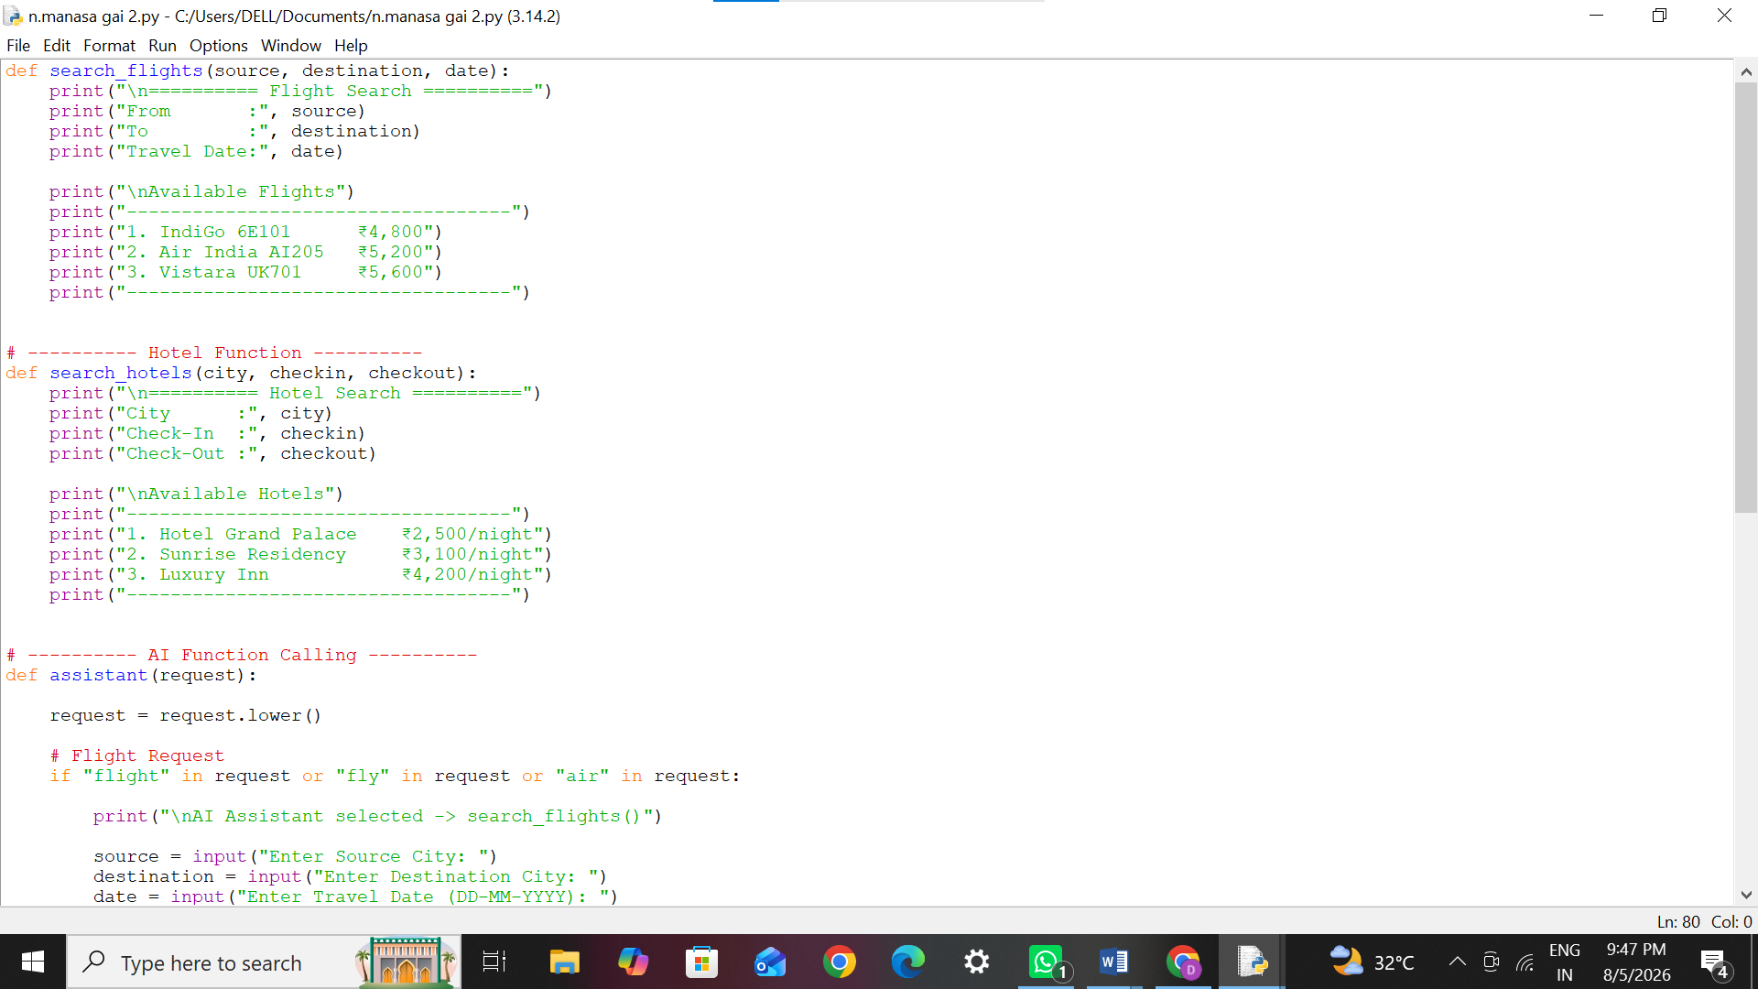
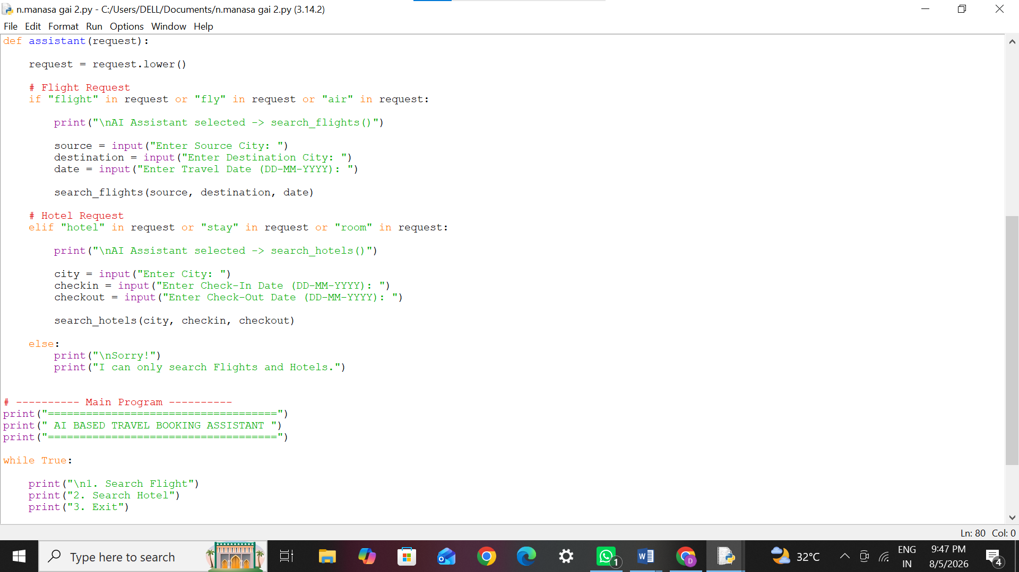

Output:

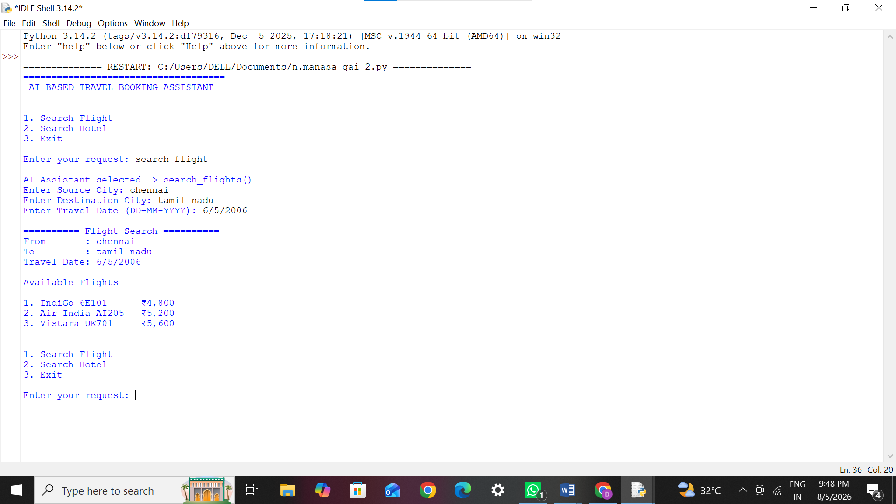

Function Calling
- Function calling allows an AI model to invoke predefined functions.
- The assistant decides which function is needed.
- Improves accuracy and automation.
- Connects AI with external APIs or databases.

Function Schema 1

search_flights()
Purpose
- Search available flights.
Parameters
- Source City
- Destination City
- Travel Date
Returns
- Flight Name
- Flight Number
- Ticket Price

Function Schema 2

search_hotels()
Purpose
- Search available hotels.
Parameters
- City
- Check-in Date
- Check-out Date
Returns
- Hotel Name
- Price
- Availability

Workflow
- User enters a request.
- AI understands the request.
- AI identifies whether it is a flight or hotel query.
- AI calls the appropriate function.
- Function returns travel details.
- Results are displayed to the user.

Test Cases
Test Case 1
- Input: Search Flight
- Function Called: search_flights()
- Result: Flight list displayed.
Test Case 2
- Input: Search Hotel
- Function Called: search_hotels()
- Result: Hotel list displayed.
Test Case 3
- Input: Book Movie Ticket
- Function Called: None
- Result: Unsupported request message.

Advantages
- Saves time.
- Easy to use.
- Faster booking process.
- Automatic function selection.
- User-friendly interface.
- Can integrate with real-time APIs.
- Reduces manual effort.

Applications
- Online travel agencies.
- Airline booking systems.
- Hotel reservation platforms.
- Tourism websites.
- Travel chatbots.
- Mobile travel applications.

Technologies Used
- Python
- Function Calling
- Artificial Intelligence (AI)
- Natural Language Processing (NLP)
- Python IDLE

Key Features
- Natural language understanding.
- Automatic function selection.
- Flight search.
- Hotel search.
- Interactive console interface.
- Easy to extend with new functions.
START
│
▼
User Enters Request
│
▼
AI Receives User Query
│
▼
Analyze User Intent
(Flight or Hotel?)
│
┌──────┴──────┐
│ │
▼ ▼
Flight Request Hotel Request
│ │
▼ ▼
Call search_ Call search_
flights() hotels()
│ │
▼ ▼
Retrieve Flight Retrieve Hotel
Information Information
│ │
└──────┬──────┘
▼
Display Results
│
▼
End / New Query

Conclusion
The AI-Based Travel Booking Assistant Using Function Calling automates travel planning by understanding user requests and selecting the appropriate function (search_flights() or search_hotels()). It provides a simple, efficient, and user-friendly way to search for travel options and serves as a foundation for integrating real-time travel APIs in future enhancements.

